**CHAPTER 01**

**INTRODUCTION**

This Project introduces a vision based object tracking robot which is driven by wheels and controlled by using Raspberry Pi as microcontroller along with Computer Vision (OpenCV). The objective of this project is to design a robot which is automatically tracks and follows an object on the basis of its colour and shape. Emphasis is given on precision vision based robotic applications using Machine Learning. Image acquisition by the robot is achieved by using a 5MP Raspberry Pi Camera Module. The video feed is sent to image processing library for further processing. The overall project describes a visual sensor system used in the field of robotics for identification and tracking of the object.

Object detection is a fundamental basis of artificial intelligence and robotic vision system. Object detection methods are used in various fields like science, engineering, medical applications. It is necessary for surveillance applications, guidance of autonomous vehicles, smart tracking of moving objects etc. This project deals with only object detection in robotics. A camera is used for image acquisition and OpenCV is used to process it. The camera works as the eye of the robot. In order to develop a stable and useful vision based robot proper study and accurate model regarding image processing are very much necessary.

**CHAPTER 02**

**BACKGROUND**

This project started with an idea to build a surveillance camera. We further added features such as mobility and object tracking. A simple surveillance camera cannot move. Hence, it captures only limited area for surveillance. Also, only a simple camera won’t be able to provide assured surveillance. Only if this camera could track an object or a person and then also move accordingly on its own, it will definitely be more useful. Hence, we decided to add up a mobility component that is the car, and this is how we started developing object tracking robot.

Our objective was to make a basic prototype for a bot that would follow people or objects. Our robot tries to find a colour and shape which is hard coded, if it finds a ball of that colour it follows it.

.

**CHAPTER 03**

**PROBLEM DEFINITION AND SCOPE**

The major drawback in today’s surveillance rests on the involvement of human operators which can easily be distracted, so we need a system which can autonomously monitor regions continuously, making decisions while identifying unwanted or obnoxious things and respond accordingly. Object tracking using computer vision is crucial in achieving automated surveillance. With advancement in robotic systems towards being autonomous surveillance robots the need for more smart thinking robots has become very essential. One of the aspect of tracking an object from its visuals has been taken up in this project Object Tracking Robot.

**CHAPTER 04**

**PROJECT PLAN**

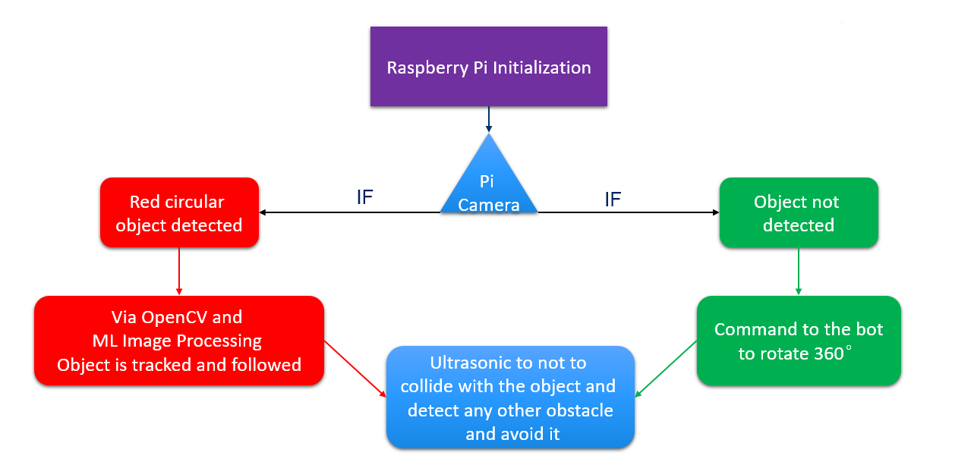

***Fig 4.1:*** *Project flow and plan.*

**CHAPTER 05**

**DETAILED DESIGN**

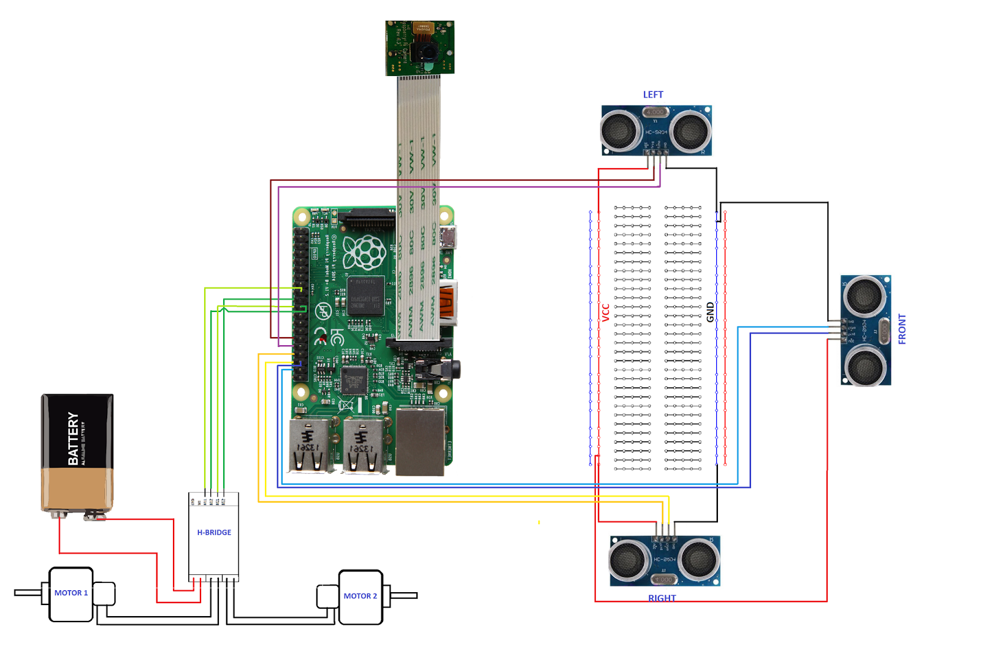

***Fig 5.1:*** *Connection Diagram.*

The robot tries to find a color which is hard coded, if it finds a ball of that color it follows it.

We have chosen raspberry pi as micro-controller for this project as it gives great flexibility to use Raspberry Pi camera module and allows to code in Python which is very user friendly and OpenCV library, for image analysis.

For controlling the motors, we have used an H-Bridge to switch from clockwise to counter-clockwise or to stop the motors. This we have integrated via code when direction and speed has to be controlled in different obstacle situations.

Crucial thing while detecting images frame by frame was to avoid any frame drops as then the bot can go into a limbo state if the bot is unable to predict direction of ball after few frame drops. Even if it manage the frame drops then also if the ball goes out of scope of the camera, it will go into a limbo state, in that case, then we have made our bot take a 360 degree view of its environment till the ball comes back in the scope of the camera and then start moving in its direction.

For the image analysis, it takes each frame and then masks it with the color needed. Then for noise reduction, we are eroding the noise and dilating the major blobs. Then it finds all the contours and finds the largest among them and bound it in a rectangle. And show the rectangle on the main image and find the coordinates of the center of the rectangle.

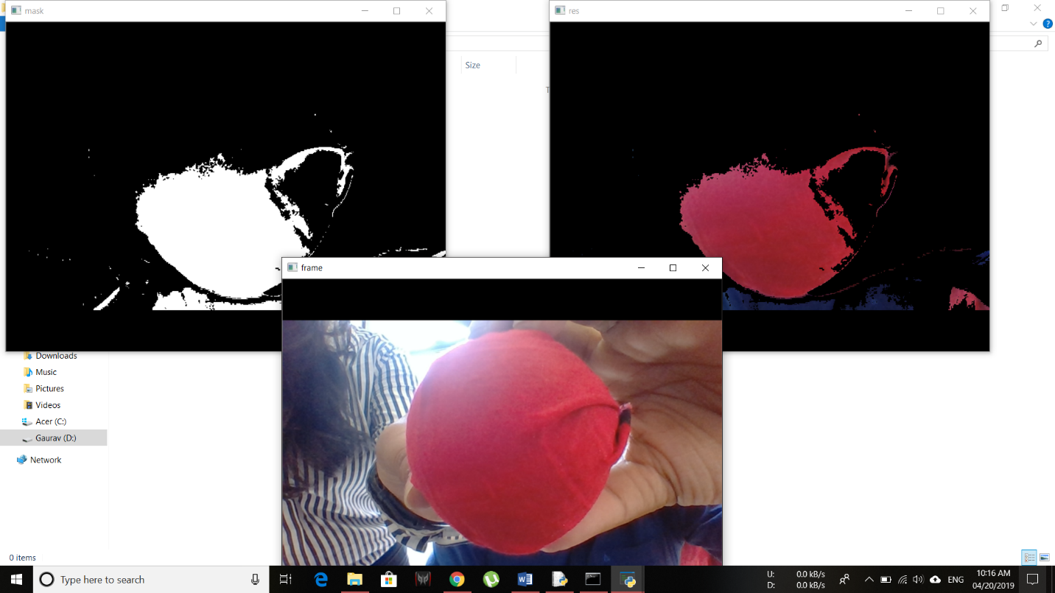

***Fig 5.2:*** *Object Detection using OpenCV.*

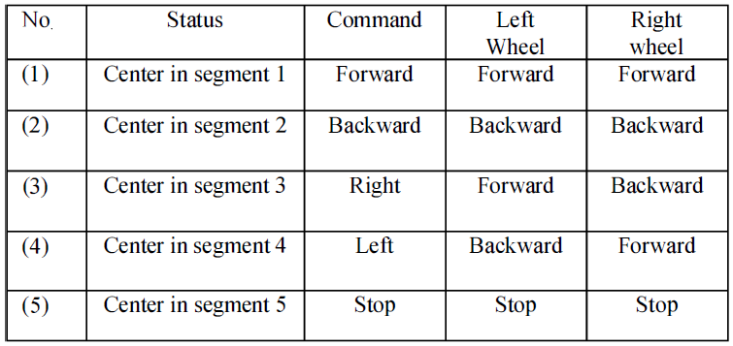

***Table 5.1:*** *Movement of Robot.*

**CHAPTER 06**

**IMPLEMENTATION AND RESULT**

**APPLICATION SNAPS/RESULTS**

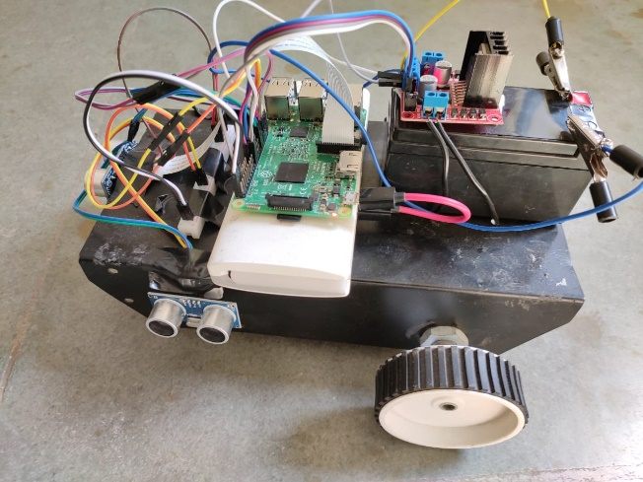 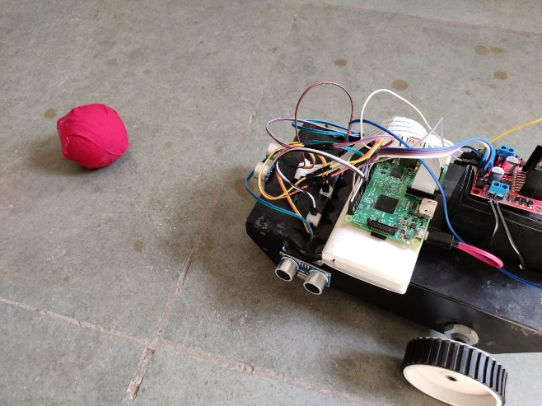

***Fig 6.1: Competed Prototype****.*

**CHAPTER 07**

**CONCLUSION AND FUTURE ENHANCEMENT**

Finally we conclude that the bot is fully capable of following any object based on its shape, size and colour. Certain improvisations can be done and this object tracking can be implemented as person following and used on product level such as suitcases, luggage trolley, spy bot, surveillance camera,etc.

**Bibliography**

1. Md.Al-Masrur Khan, Ahmadun Nabi, Abdullah-Al Nahid, Younus Ali, "Temperature Sensed Obstacle Avoiding Robot", *Electrical Computer and Communication Engineering (ECCE) 2019 International Conference on*, pp. 1-6, 2019.
2. Park, J.-W., Park, J.-H., Yun, K.-S., Lee, J.-M.: Tracking and Capturing a Moving Object Using Active Camera Mounted on a Mobile Robot. The Institute of Control, Robotics and Systems 7(9) (September 2001)
3. Jin, T.-S., Lee, J.-M.: Object Position Estimation and Optimal Moving Planning of Mobile Manipulator based on Active Camera. The Institute of Electronics Engineers of Korea 42(5), 1–12 (2005)